**Curriculum vitae**

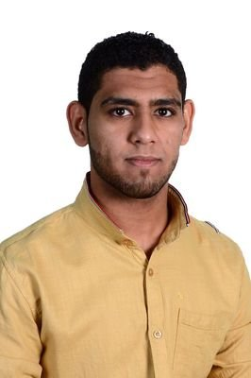

**PERSONAL DETAILS:**

Name: SALMAN MOHAMMED ABDALI MAKI  
C.P.R: 970900775  
Date of birth: 02/09/1997  
Nationality: Bahraini  
Marital status: Married

Address: H.1518 R.3628.B736AAali  
Contact numbers: 36471337

salmanalamm99@gmail.com

**Experience**

Sales man

cashier

security & hotel

security & G4S ( city center )

driver

supervisor

**PERSONAL SKILLS:**

Team working.

Positive Attitude, High Confidence and Organized.

Customer service

Good in public relation & telephone manners.

Good in English and Arabic.

I have a certiflcate of security experience from the police.

**OBJETIVE:**

Currently looking for a challenging position within your corporate company.

Planning to study university.

**EDUCATION AND QUALIFICATION:**

Hight school graguvate

**Skills:**

Excellent Organistional skills.

Excellent Analisingl& problem solving skills.

Excellent General Computer Skills.

Word, Excel, power point, typing.

**INTERESTS AND ACTIVITIES:**

Music , Drawing , Reading and travel.

**LANGUAGE:**

Arabic & English